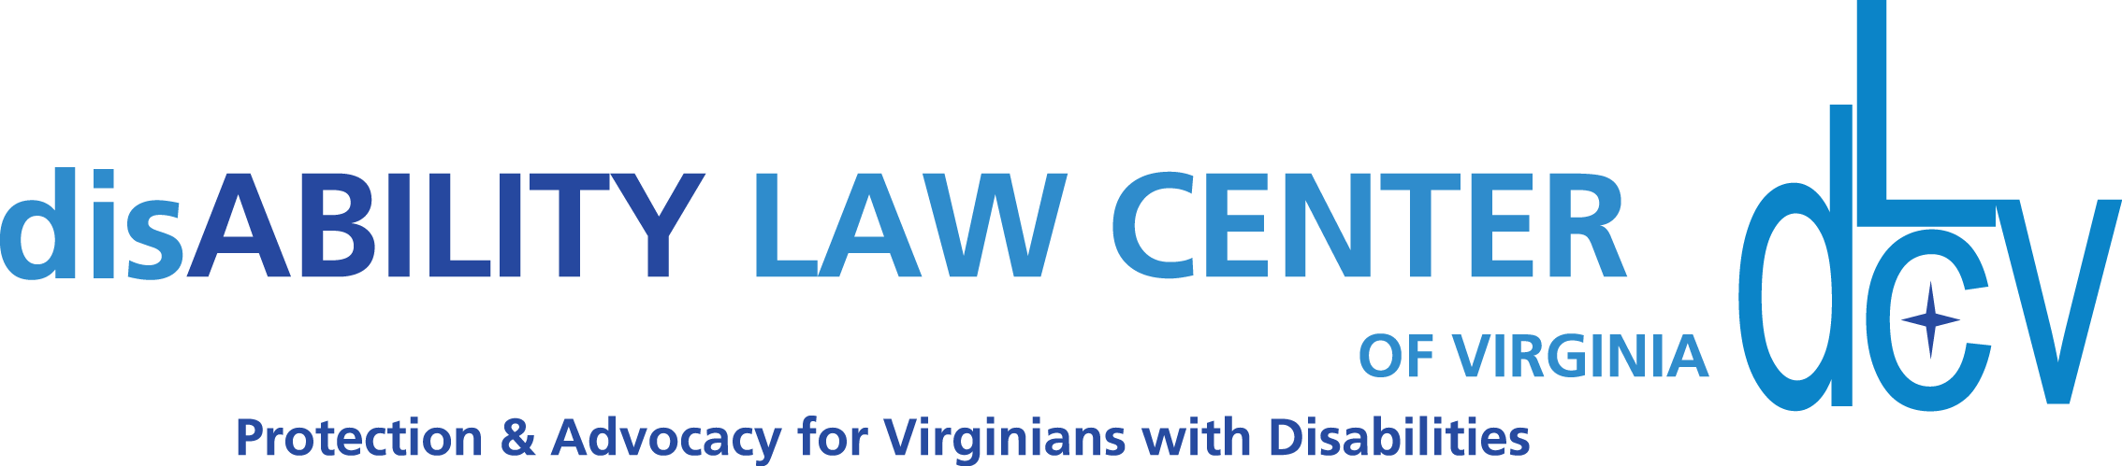

1512 Willow Lawn Dr. Ste. 100, Richmond, VA 23230 T:800-552-3962
www.dLCV.org F:804-662-7431

Things to Remember:

- You do not have need follow the suggested script exactly and can be conversational in your approach. However, if you are someone with less experience or comfort making these asks, I’d consider practicing following it exactly to see how it feels, and assess where you may want to diverge.
- It can feel like a lot of talking upfront, but be confident and take your time. Donors and organizations who are interesting in engaging do want to understand what an organization they support actually does. You have an opportunity to inform them. If they don’t want to hear it, they will let you know by not following-up or hanging up. All you can do is remain optimistic and make the ask!
- Always confirm accurate contact information. Additionally, if they mention their organization may be interested, but it is not a good time in their fiscal year to ask, ask when a good time might be for future reference. Then, provide this information to Alden, Director of External Relations (alden.blevins@dlcv.org)

Sample Phone Scripts:

(When Calling A Previous or Lapsed Sponsor… New Sponsor? Keep Scrolling!)

Hi, this is ______________. I’m calling on behalf of disAbility Law Center of Virginia about sponsorship opportunities for our annual educational Summit. We provide a wide variety of supports for Virginians with disabilities and their families, including: educational trainings, site monitoring visits, accessibility surveys, advocate-on-call services, information and referral services, statewide advocacy initiatives, curated resources and direct legal support. All of these services are free to our clients, as we are a 501©3 Nonprofit. Do you have a just a few minutes to speak with me today? (if no, go to paragraph 4)

Our free educational summit will feature 4 main tracks that speak to the needs and challenges of individuals with disabilities. These tracks and speaker topics were developed with direct feedback from our stakeholders. They include tracks focused on institutional topics, community-based service topics, transition and education service topics, and voting topics. Educational sessions will be hosted by dLCV staff and presenters from outside organizations. This event is free to the public, and we expect around 300 attendees.

Taking part in our Summit will give your organization exposure, as we dedicate quite a bit of energy, time and funding into promoting our event! Our messages will be shared on our various social media platforms, in email newsletters, and more.

Last year, your organization supported dLCV, and that money went toward programs that help people living with disabilities. Because of your support, we are able to continue our work moving towards our larger vision: A Commonwealth free of legal barriers for individuals with disabilities. On behalf of dLCV, I want to thank you for your past participation in our fundraising campaigns!

As the demand for supports and services for individuals with disabilities continues to grow, we depend on sponsors to help us fund the important work we do. We have a variety of sponsorship options that include different benefits. What’s the best email for me to send some information over to you? Our most up-to-date contact information states: [confirm email]? Excellent. Let me send that email to you now and we can go over it together and see which option will be the best fit for you! (Send Brochure)

[IF UNABLE TO REVIEW NOW] Not a problem! What’s a good time I could give you a call back to see which of the options is best for you? [Also make sure to exchange phone information. We want the best contact info to follow-up with!]

(When Calling A New-To-dLCV Sponsor)

Hi, this is ______________. I’m calling on behalf of disAbility Law Center of Virginia about sponsorship opportunities for our annual educational Summit. We provide a wide variety of supports for Virginians with disabilities and their families, including: educational trainings, site monitoring visits, accessibility surveys, advocate-on-call services, information and referral services, statewide advocacy initiatives, curated resources and direct legal support. All of these services are free to our clients, as we are a 501©3 Nonprofit. Do you have a just a few minutes to speak with me today? (if no, go to paragraph 4)

Our free educational summit will feature 4 main tracks that speak to the needs and challenges of individuals with disabilities. These tracks and speaker topics were developed with direct feedback from our stakeholders. They include tracks focused on institutional topics, community-based service topics, transition and education service topics, and voting topics. Educational sessions will be hosted by dLCV staff and presenters from outside organizations. This event is free to the public, and we expect around 300 attendees.

Last year, your organization supported dLCV, and that money went toward programs that help people living with disabilities. Because of your support, we are able to continue our work moving towards our larger vision: A Commonwealth free of legal barriers for individuals with disabilities. On behalf of dLCV, I want to thank you for your past participation in our fundraising campaigns!

As the demand for supports and services for individuals with disabilities continues to grow, we depend on sponsors to help us fund the important work we do. We have a variety of sponsorship options that include different benefits. What’s the best email for me to send some information over to you? Our most up-to-date contact information states: [confirm email]? Excellent. Let me send that email to you now and we can go over it together and see which option will be the best fit for you! (Send Brochure)

[IF UNABLE TO REVIEW NOW] Not a problem! What’s a good time I could give you a call back to see which of the options is best for you? [Also make sure to exchange phone information. We want the best contact info to follow-up with!]

