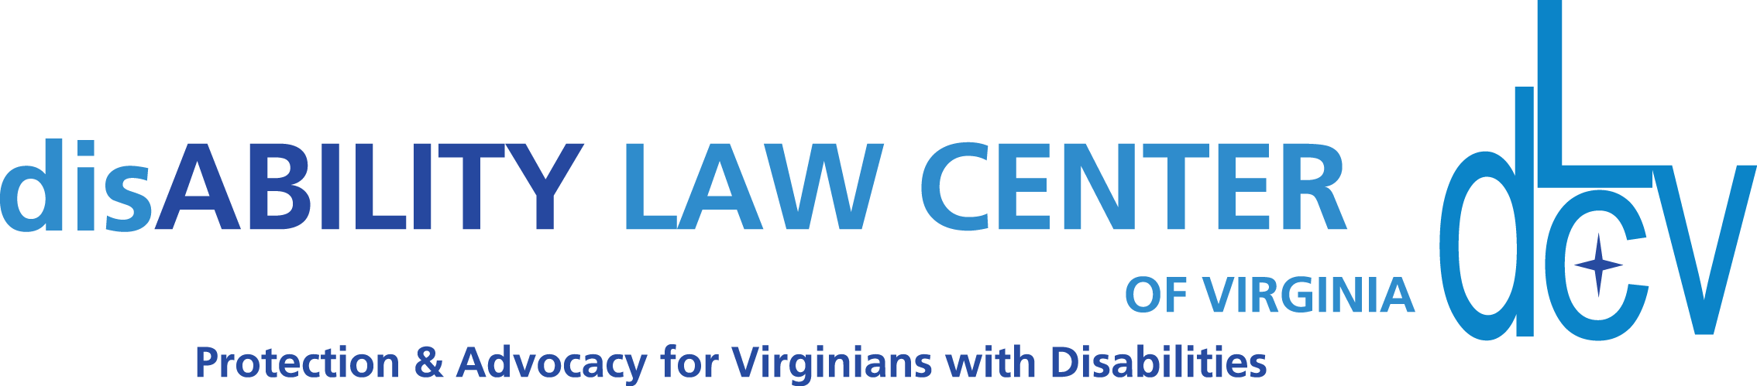

1512 Willow Lawn Dr. Ste. 100, Richmond, VA 23230 T:800-552-3962
www.dLCV.org F:804-662-7431

Sample Email Script:
Subject: Sponsoring dLCV’s 2024 Rights and Resources Summit for a more inclusive Virginia
Hello INDIVIDUAL OR ORGANIZATION NAME,
My name is FILL IN BLANK, and I’m reaching out on behalf of the disAbility Law Center of Virginia! We are the state-designated protection and advocacy organization for Virginians with disabilities.
The disAbility Law Center of Virginia (dLCV) will virtually host a disAbility Rights and Resources Summit on October 10th, 2022 from 9:00 am - 5:00 pm. We will attract attendees from across the Commonwealth who are interested in learning more about the available resources and services that dLCV and our partnering organizations offer to members of the disability community.
Our free educational summit will feature 4 main tracks that speak to the needs and challenges of individuals with disabilities. These tracks and speaker topics were developed with direct feedback from our stakeholders. They include tracks focused on institutional topics, community-based service topics, transition and education service topics, and voting topics. Educational sessions will be hosted by dLCV staff and presenters from outside organizations. This event is free to the public, and we expect around 300 attendees.

Taking part in our Summit will give your organization exposure, as we dedicate quite a bit of energy, time and funding into promoting our event! Our messages will be shared on our various social media platforms, in email newsletters, and more. I
Through your support:
- Residents of Virginia will learn more about available resources, services and legal protections for people with disabilities.
- People with disabilities and their loved ones will connect with community resources that support independent and integrated community living.
- Attendees will learn more about disability issues and how we, together, can move closer towards our vision: a Virginia free of legal barriers for individuals with disabilities.
dLCV is registered with the Internal Revenue Service as a 501(c)3, which makes donations tax-deductible. To learn more about our organization, visit our website: www.dlcv.org
I’m attaching our Summit Sponsorship Packet for your review; please let me know your thoughts! Even if the answer is “not this year” or “ we’ve spent our budget – ask again around this date” - the information is helpful to us.

Best,

FILL IN BLANK

