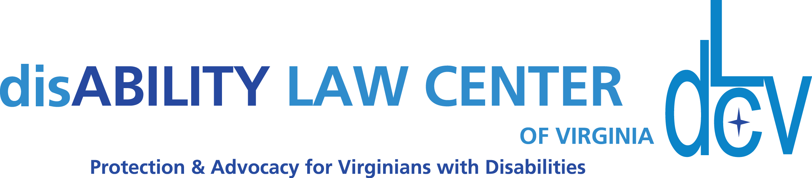

1512 Willow Lawn Dr. Ste. 100, Richmond, VA 23230 T:800-552-3962

[www.dLCV.org](http://www.dLCV.org) F:804-662-7431

**Sample Email Script:**

***Subject: Join us for an in-person event near you!***

Hello **INDIVIDUAL OR ORGANIZATION NAME**,

My name is **FILL IN BLANK**, and I’m reaching out on behalf of the **disAbility Law Center of Virginia**! dLCV is the state-designated protection and advocacy organization for Virginians with disabilities.

Want to meet more members of Virginia’s disability community? Join us Thursday, September 19th, 2024 from 5:30 to 6:30 p.m.

The disAbility Law Center of Virginia is having a meetup to thank our wonderful supporters, to give folks a glimpse into the important work dLCV is currently doing, and to build connections with members of Virginia’s disability community around the state. This would be a great opportunity for you to learn about dLCV’s services, and for us to learn from the community we serve. We have look forward to an evening of mingling and meaningful conversation.

The Garage Brewery has been kind enough to host our meet-up. Craft beers will be available on draft for purchase, and Moontide Sundries, a local food truck, will serve up some brunchy favorites! Stick around after our event for Music Bingo.

If you are able to attend, we welcome you to please kindly RSVP at the link below.

We will also use these RSVPs to communicate additional information regarding directions, parking and accessibility; so please use an email you access frequently when completing your RSVP registration.

**RSVP Here:** <https://dlcv.salsalabs.org/hrmg2024>

**Who We Are**

The disAbility Law Center of Virginia is the designated Protection and Advocacy organization for Virginians with disabilities.

We provide various services free of charge, including:

* Information and referral
* Legal representation
* Technical assistance
* Short-term assistance
* Systemic advocacy within the Virginia General Assembly
* Institutional monitoring of facilities that serve people with disabilities
* Training and educational programs

Although our work is primarily funded by federal grants, community support is crucial to meeting the growing needs of our community. Our federal grants have been level-funded year-over-year. As our agency’s operating costs continue to rise with inflation, your donations help supplement this funding. This allows us to preserve the quality of our services, as well as the number of people we are able to serve.

**What We Do**

We’re so glad you asked! Here is a short list of some of our highlights over the last year:

* Determined **accessibility compliance in voting**, which involved surveys of other 550 polling locations.
* Reached **25,304 individuals** through our **training programs.**
* Reviewed **21,225 Serious Injury Reports and 5,450 Abuse and Neglect Reports** submitted from various facilities for people with disabilities across the state.
* Provided **information, resources and referral** to **2,442 individuals**.
* Supported **57 clients** in seeking **employment supports** via our Client Assistance Program and Vocational Rehabilitation Services.
* Educated **230 registered attendees** at our annual fall Rights & Resources Summit on topics like systemic disability factors, education, employment rights, community resources and intersectionality issues that impact the disability community.

**Why Donate?**

Well, this one’s a bit up to you! Do you have someone who you love who is impacted by disability? I bet you do, even if you don’t realize it! **Part of the reason we still need disability pride movements is because there is immense stigma surrounding discussing these issues**. Getting out in the open about perspectives of the can serve as validation for others with their own disabilities and normalize our lived experiences for the next generation

According to the CDC, **1 in 4 US adults live with a disability**. This means that **everyone knows someone** impacted by the living conditions, opportunities and programs that are available to individuals with disabilities. Disability impacts all of us; and if we wish to remain committed to a more inclusive and equitable society, disability must be a part of the conversation.

Thanks for your consideration,

**FILL IN BLANK**

**Sample Text or Informal Message:**

Hello, **FILL IN BLANK**!

The disAbility Law Center of Virginia is hosting an event near you! Join us for happy hour at The Garage Brewery for a dLCV meetup. Connect with VA’s disability community, learn about our work, and enjoy craft beer & food from Moontide Sundries.

<https://dlcv.salsalabs.org/hrmg2024>

Thank you! 💙

* **FILL IN BLANK**